2.4 More Modeling with Functions

Review of Linear Functions

- A line passes through points (1, 8) and (3, 14)
  - What is the slope?
  - What is the equation in slope-intercept form?
  - What is the y-intercept?

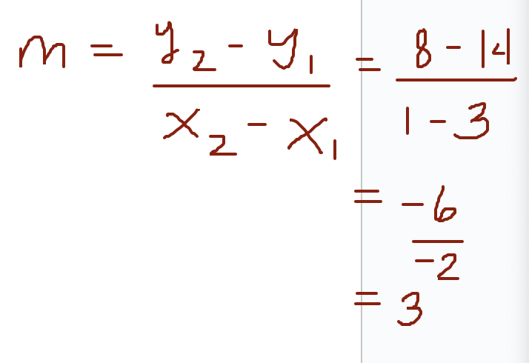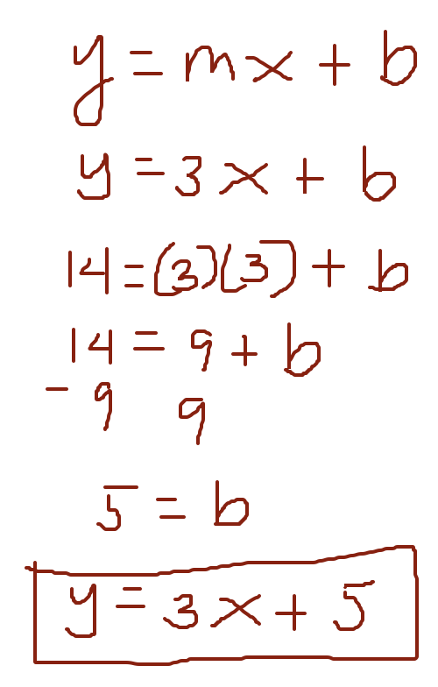

Since the slope intercept form is y = 3x + 5, the y-intercept is 5, because for y = mx + b, the b is the y-coordinate of the y-intercept (0, 5).

Finding the Domain and Range
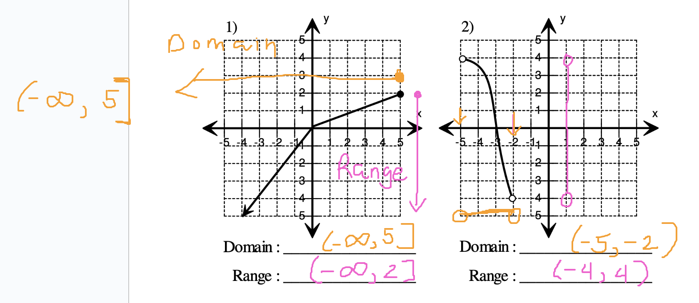

Modeling with a Linear Function
To model a quantity that is changing at a constant rate with f(x) = mx + b, the following formula may be used.
f(x) = (constant rate of change)x + initial amount
y = mx + b
m is the constant rate of change
b is the initial amount

The constant rate of change corresponds to the slope of the graph of f, and the initial amount corresponds to the y-coordinate of the y-intercept.

Example: Finding a Symbolic Representation
A 100-gallon water tank, initially full of water, is being drained at a rate of 5 gallons per minute.
constant rate of change = -5 gallons/minute
initial amount = 100 gallons
a. Write a formula for a linear function f that models the number of gallons of water in the tank after x minutes. y = f(x) = -5x + 100
b. How much water is in the tank after 4 minutes? What is f(4)? f(4) = -5(4) + 100 = -20 + 100 = 80 gallons. After 4 minutes, there will be 80 gallons left in the tank.
c. Graph f. Identify the x- and y-intercepts and interpret each.
d. Discuss the domain and range of f.

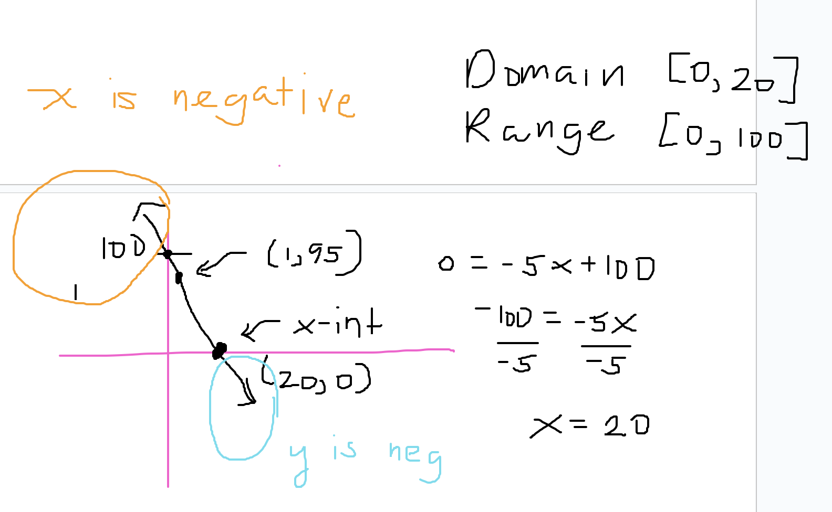

y-intercept is 100, because at time x = 0 minutes, the tank initially contained 100 gallons.
x-intercept is 20, because after x = 20 minutes, the water tank becomes empty (or f(x) = 0).

Piecewise-Defined Functions
A piecewise-defined function is a function f _________________________________________.

If each piece of the function f is linear, then f is called a piecewise-linear function.

Example: Fujita Scale of Tornadoes

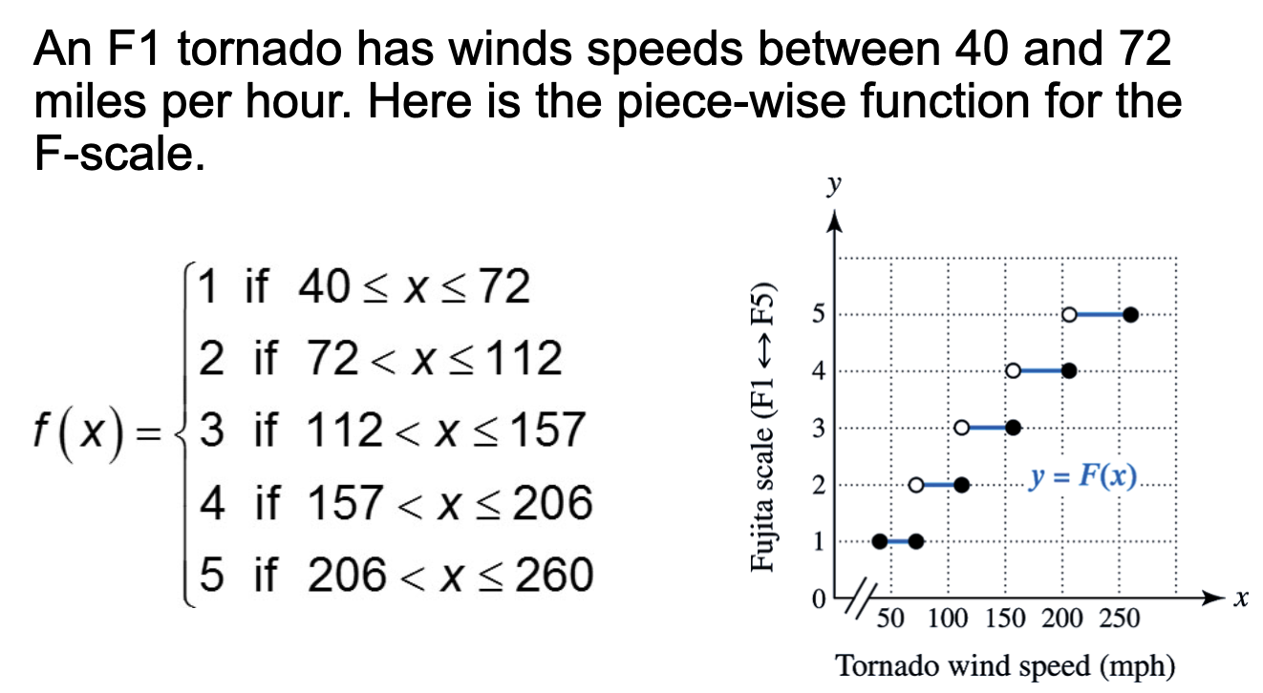

Question: How would we classify a tornado on the Fujita scale if the tornado has a wind speed of 130 miles per hour? How about one with speeds of 150 miles per hour?

Evaluating and Graphing a Piecewise-Defined Function.

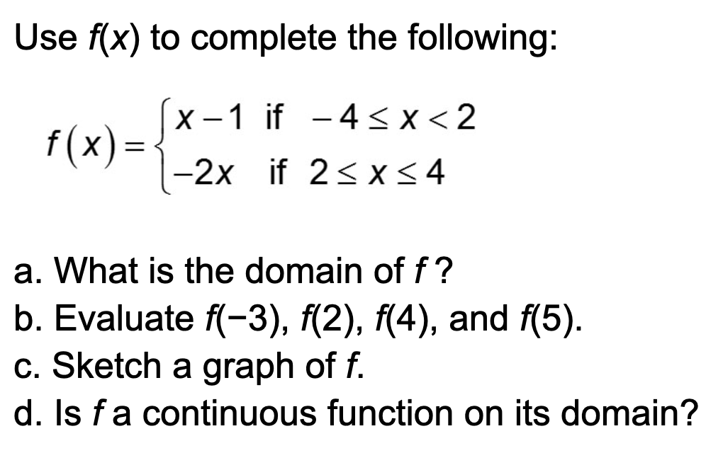

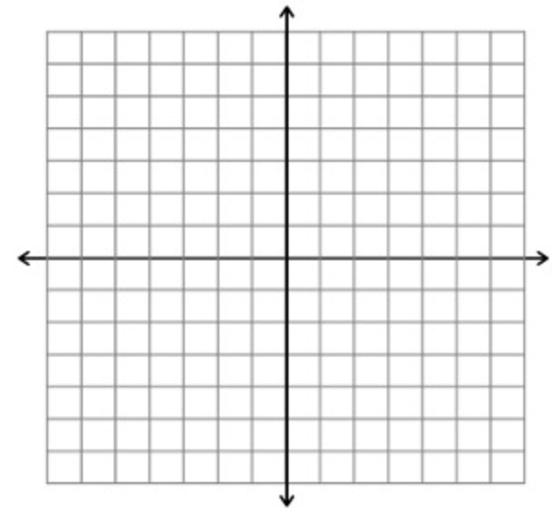

Direct Variation

Let x and y denote two quantities. Then y is directly proportional to x, or y varies directly with x, if there exists a nonzero number k such that

y = kx.

The number k is called the constant of proportionality or the constant of variation.

When solving a variation problem, the following steps can be used.
STEP 1: Write the general equation for the type of variation problem that you are solving.
STEP 2: Substitute given values in this equation so the constant of variation k is the only unknown value in the equation. Solve for k.
STEP 3: Substitute the value of k in the general equation in Step 1.
STEP 4: Use this equation to find the requested quantity.

Example: Solving a Direct Variation Problem
Let T vary directly with x, and suppose that T = 33 when x = 5. Find T when x = 31.

Hooke's Law
Hooke’s law states that the distance that an elastic spring stretches beyond its natural length is directly proportional to the amount of weight hung on the spring, as illustrated.
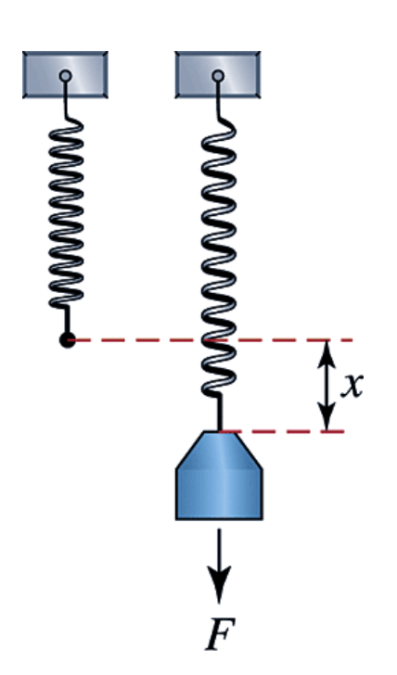

This law is valid whether the spring is stretched or compressed.

The constant of proportionality is called the spring constant. Thus if a weight or force F is applied and the spring stretches a distance x beyond its natural length, then the equation F = kx models this situation, where k is the spring constant.

A 12-pound weight is hung on a spring, and it stretches 2 inches.
a. Find the spring constant.
b. Determine how far the spring will stretch when a 19-pound weight is hung on it.

